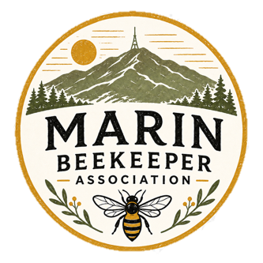
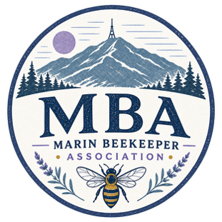
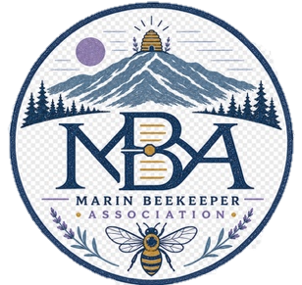

Marin County Beekeeper Association

Board of Directors Meeting Minutes — DRAFT (Unapproved)

Date: September 1, 2026
Time: 6:00 PM – 8:30 PM (scheduled)
Location: Private residence of Board Director Dana Pepp, San Rafael, CA

Directors Present:
- Paul Reulbach (Board Chair and President)
- Gary Denison (Treasurer)
- Jim Lawson (Membership Director)
- Dana Pepp (Community Outreach and Volunteering Director)
- Tom Pillsbury (Community Outreach and Volunteering Director)
- Justin Strom (Education Director)
- Sylvia Watkins (Board Secretary)

Quorum: present (7 of 7 directors).

Absent:
None

Agenda

I. Call to Order 3
II. Approval of Previous Minutes 3
III. Motions Voted on and Passed 3
IV. Ratification of August Board Actions Conducted by Email 3
V. Topics Presented for Discussion 3
2. Club Vision and Mission Statements 4
3. Club Logo and Swag 4
4. Club Culture 5
5. Club Liability 5
6. Membership 6
7. Club Meeting Topics, Format, and Locations 7
8. Website Update 7
VI. Action Items – All due by next meeting October 15, 2026 8
VII. Next Meeting 9

Call to Order
Board Chair Paul Reulbach called the meeting to order at 6:30 PM. A quorum of directors was present.

Approval of Previous Minutes
No vote was taken on the minutes of the July 23 Board meeting. The Board agreed to approve the minutes by email vote. The Secretary will circulate the minutes for approval by October 15, 2026.

Motions Voted on and Passed
- Motion: To approve payment of the location liability insurance premium. Moved by Paul Reulbhach, seconded by Tom Pillsbury
  - Vote: Motion carried unanimously
  - Action: Gary Denison (Treasurer) to pay the insurance invoice by October 15, 2026.

- Motion: To accept the July financial report as presented and summarized in the July 23rd meeting minutes. Moved by Dana Pepp, seconded by Tom Pillsbury
  - Vote: Motion carried unanimously
  - Action: Gary Denison to file the July financial report with the Association’s records held by Jim Lawson (Membership Director).

Ratification of August Board Actions Conducted by Email
“No email actions required ratification.”

Topics Presented for Discussion
- Icebreaker and team building: Directors took part in a get-to-know-you activity at the start of the meeting.

Club Vision and Mission Statements
The following vision and mission statements were drafted:
Vision:
Honeybees are recognized as a vital part of our TBD (ecosystem OR our existence).
Mission:
To educate and increase interest in beekeeping through learning, mentorship, and community engagement.
Next steps: The Board will conclude discussion on the Vision and Mission Statement at the next Board Meeting in October

Club Logo and Swag
    - Jim Lawson will add a call for graphic artists, children, and any interested members to submit logo designs for the Association in the next MBA newsletter.
    - Paul Reulbach identified a Marin resident who operates a T-shirt and merchandise business and can supply swag once the logo is finalized. Paul Reulbach will negotiate club pricing and present a proposal at the next meeting.
    - Paul Reulbach suggested developing specific lanyards and tags for Board members.
    - Association cards: Tom Pillsbury will add the meeting dates to the printed cards.

Club Culture
Goal: Create a positive and dynamic club culture.
- Increase volunteerism so the Association is represented at fairs, schools, and other educational events.
- Discussed the potential to allow volunteers to sell their honey at the Marin fair if they do a shift.
- Identify and welcome back members who left MBA due to past management style (all Board members) – Use Hive Dive and other similar workshops and educational opportunities to attract former members back.
- Discussed the culture and membership of the Alameda and the Sonoma Clubs, each with more than 500 members, to identify opportunities for MBA to grow.

Club Liability
  - All Board Directors: Identify a member or friend of the Association with a legal background to advise the Board and help draft liability disclaimers.
  - EpiPen training and certification: Paul Reulbach will research local training options for members. Target date – the next board meeting (October 15, 2026).
  - Hive dives:
    - Sylvia Watkins will draft a document defining the roles and responsibilities of hosts, guests, and mentors (by October 15, 2026).
    - A release-of-liability form is needed when members sign up for hive dives; such document will need review by the Legal specialist identified by Board Directors.
  - Swarm calls:
    - Members who take swarm calls represent the Association. Develop and publish a swarm-call playbook on the website. [CONFIRM: owner.]
    - A swarm list agreement is needed to clarify that members responding to swarm calls act in their own capacity. [CONFIRM: owner.]
    - Both documents listed above will require review by legal counsel.

Membership
Goal: Grow membership and generate revenue for the Association.
- The Board will set a numeric membership target effective January 1, 2027.
- Seek to offer activities that encourage members to return, including workshops, lectures, and hands-on sessions.
- Use Facebook campaigns to identify and target residents on social media who have expressed interest in honey, bees, pollination, and other beekeeping-related keywords.
- Paul Reulhbach suggested pulling an active members list (paid members) from “the buzz email list” and sending a campaign to non-paying members or previous members who have not renewed and do not attend meetings, highlighting the benefits of membership.
- The active members list will also be used to verify that people attending Hive dives are active members only.
- Renewals:
  - MBA needs to confirm which members have paid their dues.
  - The President will validate the paid-member list. At the September club meeting, Tom Pillsbury and Jim Lawson will check members in at the door.
- Sponsorships/ Allies:
  - The Board discussed approaching businesses and individuals who would pay for access to the membership.
  - Businesses and individuals currently using the MBA mailing list to find extraction opportunities should pay a fee to MBA for the information (e.g., Claire Logier).
  - Hive Track was raised as a potential sponsor or partner.
  - Researchers could pay for membership access to trial new products.

Club Meeting Topics, Format, and Locations
  - September 3, 2026:
- Treasurer (Gary Denison) will introduce the new Board members: Paul Reulbach as Chair and President and Sylvia Watkins as Board Secretary.
- November 5, 2026:
  - Justin Strom organized a pollinator partnership teaching opportunity facilitated by the garden club (Presenter: Jennifer Radtke).
  - May 6, 2027:
    - Tom Pillsbury will organize a presentation and meeting at the Heidrun Meadery in Point Reyes.
  - The Board agreed that a circle format is the best way to open club meetings.
  - Club meetings should start on time.

Website Update
  - Recruit a webmaster – All Board members
  - Add a members’ area with:
        - Details of the equipment available for loan (description, photos, the member storing each item, and how to book it)
        - A calendar on which active members only can book equipment
        - An FAQ — and, ideally, videos — covering how to use the equipment, how to prepare the space, and how to clean the equipment after use
        - Links to expert videos, lectures, and blogs (for example, Bonnie’s video series)

Action Items – All due by next meeting October 15, 2026
Owner | Activity
Gary Denison (Treasurer) | Pay the location liability insurance invoice.
Gary Denison (Treasurer) | File the July financial report with the Association’s records.
Sylvia Watkins (Secretary) | Circulate the September 3, 2026, minutes for approval by email vote.
Sylvia Watkins (Secretary) | Draft the roles and responsibilities for hive dive hosts, guests, and mentors.
Paul Reulbach (President) | Negotiate swag pricing with the local merchandise vendor and bring a proposal to the next meeting.
Paul Reulbach (President) | Research EpiPen training and certification options for members.
Paul Reulbach (President) | Validate the list of paid members.
Tom Pillsbury (Community Outreach and Events) | Add meeting dates to the Association cards.
Tom Pillsbury (Community Outreach and Events) | Check members in at the door at the September club meeting.
Justin Lawson (Membership) | Publish the call for logo designs in the next newsletter and at the September club meeting
All | Identify a member with a legal background to advise on disclaimers.
All | Draft a release of liability form for hive dives.
All | Draft the swarm call playbook for the website and the swarm list agreement.
All | Recruit a webmaster and scope the members’ area of the website.
All | Seek membership feedback on the proposed vision and mission statements.

Next Meeting
Date: October 15, 2026 | Time: 6:00 PM | Location: Zoom

There being no further business, the meeting was adjourned at 8:30 PM

Respectfully submitted,
Sylvia Watkins
Secretary
Marin County Beekeeper Association

